MiCorps Volunteer Stream Monitoring Program

Monitoring Fact Sheet
Organization Name:

Monitoring Program Name:

Watersheds Monitored:

County(ies):

Program Manager: give name and contact info!

Fact Sheet Updated: date
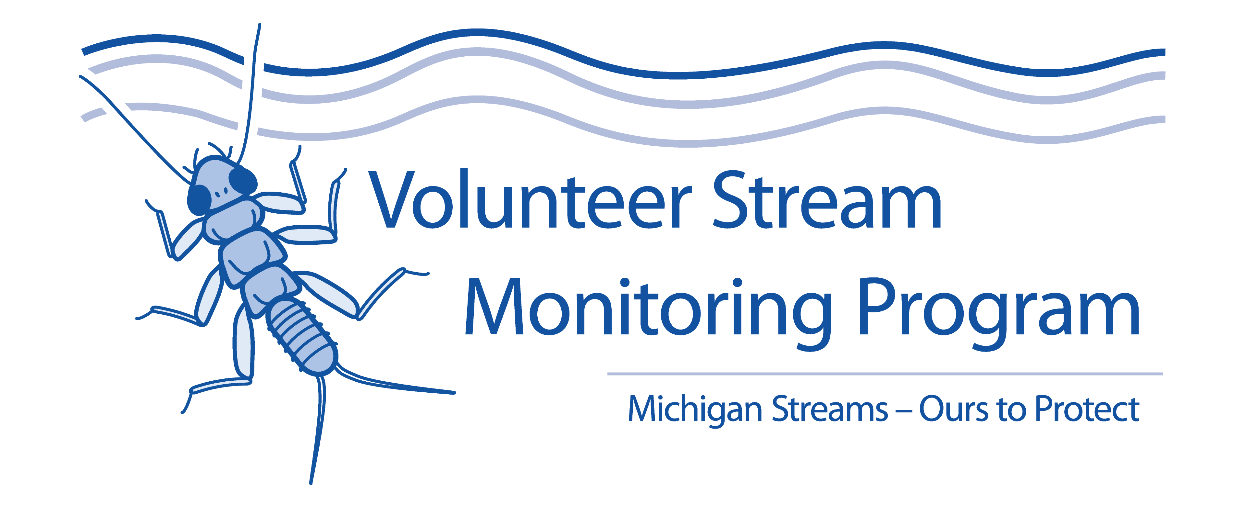

If desired, insert your organization’s logo here

PROGRAM DESCRIPTION: (Directions: a paragraph that can be kept constant as you update this yearly)

Insert a picture here!
PROGRAM FAST FACTS

# of Years Monitoring:

# Volunteers participating annually:

# Active Monitoring Sites:
# Excellent Quality Sites:
# Very Good Quality Sites:
# Good Quality Sites:
# Fair Quality Sites:
# Fairly Poor Quality Sites:
# Poor Quality Sites:
# Very Poor Quality Sites:

Link to Monitoring Program: website link

Link to Quality Assurance Plan: website link

RESULTS

Spring 2021 Fall 2021
Site Name, Lat/Long or Address
WQR:
Comments:

Site Name, Lat/Long or Address
WQR:
Comments:

Site Name, Lat/Long or Address
WQR:
Comments:

Site Name, Lat/Long or Address
WQR:
Comments:

Site Name, Lat/Long or Address
WQR:
Comments:

Site Name, Lat/Long or Address
WQR:
Comments:

Site Name, Lat/Long or Address
WQR:
Comments:

Site Name, Lat/Long or Address
WQR:
Comments:

Site Name, Lat/Long or Address
WQR:
Comments:

Site Name, Lat/Long or Address
WQR:
Comments:

Site Name, Lat/Long or Address
WQR:
Comments:

Site Name, Lat/Long or Address
WQR:
Comments:

